Scout Rank:
First Rank to complete will be the rank of Scout. (Link below will show the requirements along with the items to memorize). These can be found in the Scout Handbook or online at:
https://www.boyscouttrail.com/boy-scouts/scout-scouts.asp
Work on your own to memorize the Scout Oath, Scout Law, Scout motto, Scout Logan and the Outdoor code.

Uniform:
All items can be found on the BSA Scout Shop website at:
https://www.scoutshop.org/uniforms/scouts-bsa/boys.html

Class A uniform pants: (please note that you can purchase similar pants elsewhere as long as the color is similar.
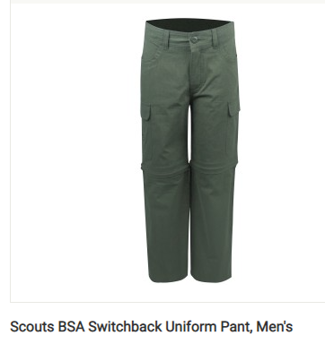
Class A uniform Socks: (please note that you can purchase similar socks elsewhere as long as the color is similar.
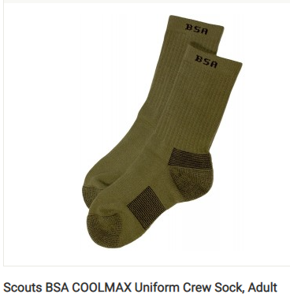

Class A uniform shirt: (no patches.) – Official scout shirt should be purchased. (NOTE: Once the scout shop in Allentown reopens, you may be able to get the shirt with some/all patches already sewn on).
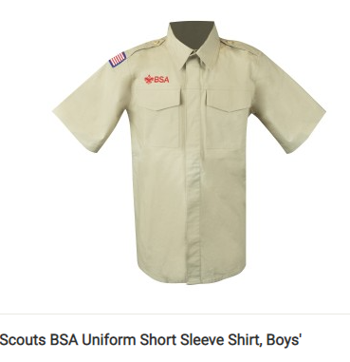
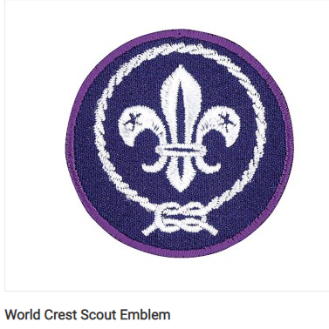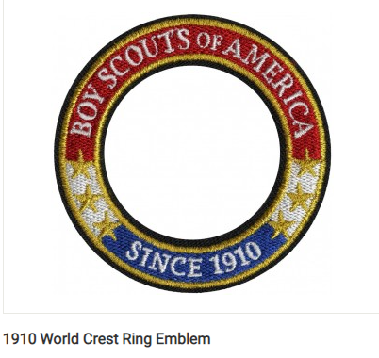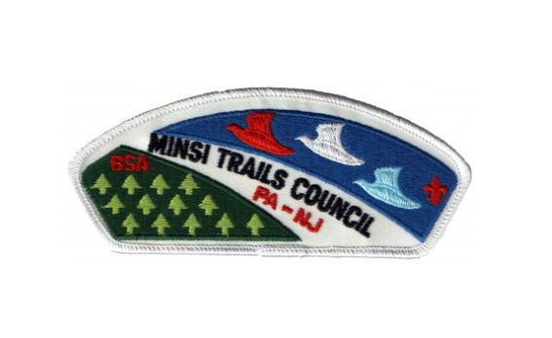
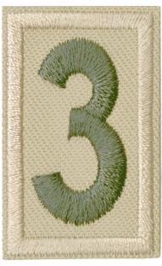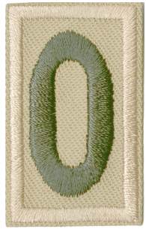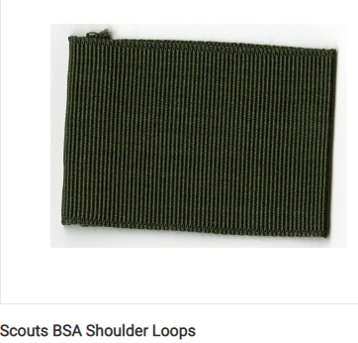

Class A uniform Belt:
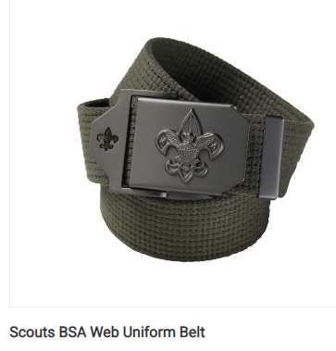

Class A uniform Hat:

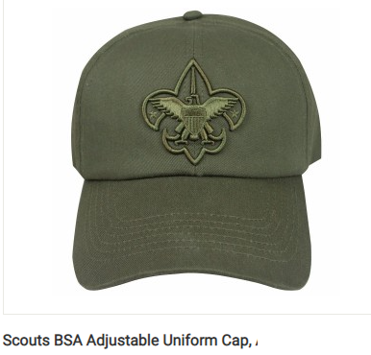

Slide and Neckerchief: I need to find out where we get them from.

Handbook:
